<https://oit.duke.edu/service/panopto/>

Hock 214 and Hock 10089 have Panopto Remote Recorders. You will need to be added to them.

Hock 214 (CRTP-Hock-214 (CDSS-DQKX7YE) (136.226.53.9))

Hock 10089 (Biostat 10089 (CDSS-64X01R3) (136.226.53.33)

To schedule a recording for one of the classrooms with a remote recorder, click “+Create” and choose “Scheduled Recording”

If this is a regular class, you will want to choose “Repeat Recording” and then how often and until when.

Most of the classes have a folder under the folder CRTP. If not, create one.

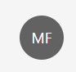To get a Zoom call to automatically convert to Panopto without the call being routed through a classroom recorder:

Click the profile circle in the top-right corner:

Choose “User Settings”

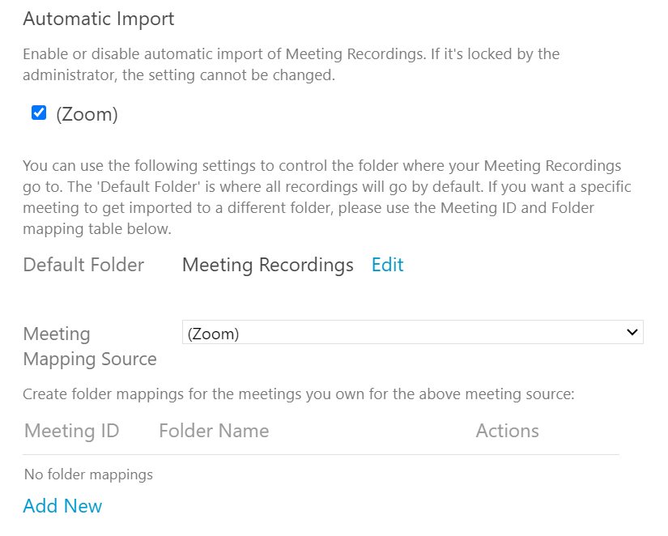

Click “Add New” Then choose the correct folder and input the zoom meeting id in the box under “Meeting ID”

After creating a folder, you can adjust the sharing settings, as well as other settings. One setting of note, under the “settings” tab:

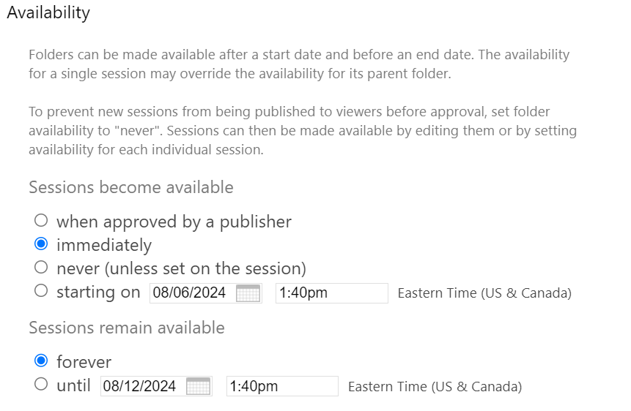

You can set when things become available. Some course instructors do not want things to be available until a student requests to see the recording and the instructor gives permission. For individual videos, or to set a delay, you can set the folder to never and then go in and change the availability on the video itself.